Try to map the ERD and then create DB with the following Constraints:

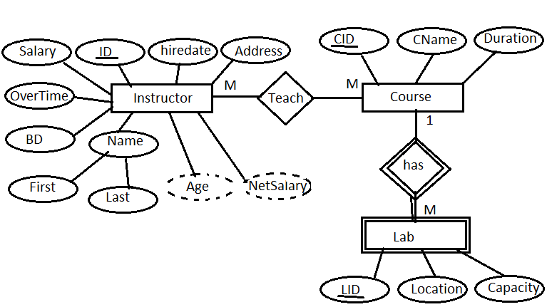

* All Ids are Identity
* All Foreign keys are not identity
* All foreign keys have cascade rule on delete and update
* Age and Netsalary are calculated attributes but it will be on instructor table creation
* Netsalary=salary+overtime
* Age=current year – birthdate year
* Address has only cairo or alex value
* All salaries in the range from 1000 to 5000
* Salary has a default value = 3000
* Overtime is unique
* Capacity of each lab under 20 seats
* Lab is weak entity
* Hiredate has a default value= current system data
* Duration of each course is unique

1. Create a view that will display Instructor Name, Department Name for the ‘SD’ or ‘Java’ Department
2. Create a view “V1” that displays student data for student who lives in Alex or Cairo.

Note: Prevent the users to run the following query

Update V1 set st_address=’tanta’

Where st_address=’alex’;

1. Create a view that will display the project name and the number of employees work on it. “Use Company DB”
2. Write a query to select the highest two salaries in Each Department for instructors who have salaries. “using one of Ranking Functions”
3. Write a query to select a random student from each department. “using one of Ranking Functions”